**NEW ORDERS**

1. **Order type: Can we change the order type based on what the PO states?** 
   * 5 days, Blanks,24-hour, 48-hour, 2 weeks air, etc.

YES

1. **Contact: Is AI able to add a new contact in NetSuite, including email and phone number?**

**YES but what are the parameters to add a new contact , what triggers this creation?**

1. **Estimated Ship Date: Calculate estimated ship date based on order type**

**Need more details**

1. **In Hands Date: Add in hands date based on date on PO**

**Need more details**

1. **Shipping Method: Is this fixed? YES**
2. **Ship to address: Has this been fixed? YES**
3. **Proof: Please add line item as a standard if PO requests a proof. OK**
4. **Run charges: Add to the order based on customers PO. These are being added but will review**
5. **TXT standard text: Is AI able to add this as a line item? yes**

**PLEASE NOTE**

1. Please review your order details and let us know of any discrepancies.
2. If you requested a proof, it will be sent within 24 hours.
3. 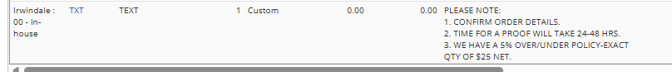We have a 5% over/under policy. For exact quantity shipping, add a $25 net fee—please notify us if you prefer this.
4. **OZLINK: we need to find the shipper number it is not standard placement** 
   * **Fill in 3rd party shipper#**
   * **Check off “Bill Shipping to 3rd Party”**
5. **Art Instructions: Updated based on information on PO as best as possible**
   * **Can we leave it blank if there is no answer?** 
     + 1. Imprint Color -   
       2. Imprint Method -   
       3. Logo Name -   
       4. Logo Size -   
       5. Proof-

OK

**FACTORY DIRECT ITEMS**

1. **Integrate FD items into orders: what do you need from us? Show us your process**

* **Change order type based on PO**
* 2 weeks air, 10 weeks ocean, 8 weeks ocean, 6 weeks air, etc.

**ok**

**MISSING ARTWORK**

1. **Can AI send a reminder about artwork? Yes but let’s define this**
2. **Can AI send the order acknowledgment once the order moves to “Art Screen” more details but yes**